Just about every first world country is grappling with the problem of excessive unwanted immigration. In writing this book for his German speaking audience, Martin Sellner discusses the problem as it affects countries throughout the world.
The United States has just elected Donald Trump, giving him a mandate to address the problem in the United States. Though the history and the particulars are different, the overall structure of the problem is similar. This book can do a lot to inform the argument in the United States.
The problem of the Turks in Germany was evident 50 years ago when I the reviewer lived in Frankfurt. They had been brought in by Ludwig Ehrhardt as part of the “business miracle.” The theory was that they would integrate and become German. Sellner reports that they have not.
This is disappointing but not surprising. The Turks are more European than other Muslim nations. They are culturally more similar to Europeans. They are more intelligent, with an average IQ around 89. Compare that with other homelands of migrants to Germany such as Syria with an IQ of 73 or so and Pakistan and Afghanistan around 81. In other words, if any Muslim population should have been prepared to integrate with the Germans, it would’ve been the Turks. The fact that they did not is telling us something. Given that Sellner’s book is intended for a broad and often socially liberal German audience he cannot afford to cite facts such as this, though he certainly knows them.
While Sellner does not address the North American situation, it is worth noting that this same source, reflecting the culmination of more than a century’s research, finds that the average intelligence of Mexico and Venezuela are also just above 80. Given that the bulk of the illegal immigration is from the lower strata of these societies, one can conclude that the incompatibility that Sellner notes in Germany is pretty much the same as that being experienced by migrants coming to the United States. The major difference, and it is a major factor, is that the immigrants to the United States do not adhere to a militant, xenophobic religion.
Given that few who read this will want to read the original German, this is more of a condensed book than a review. The bolded and numbered paragraphs are Sellner’s chapter titles. Those that are simply bolded are his subheads. The plain text is a synopsis of the contents.
1. Basics
What is remigration –
Remigration is not expulsion. It is encouraging migrants to go back home.
Population policy today
The reigning population policy in Germany today is replacement migration. It is a historically unique experiment, enforced by a political dogma. Without it Germany would have 70 instead of 83 million inhabitants, and Austria 7 instead of 9.
The countries are approaching a tipping point. Not only are there too many immigrants, but they are overwhelmingly young and male. Unless we do something now, we will lose control.

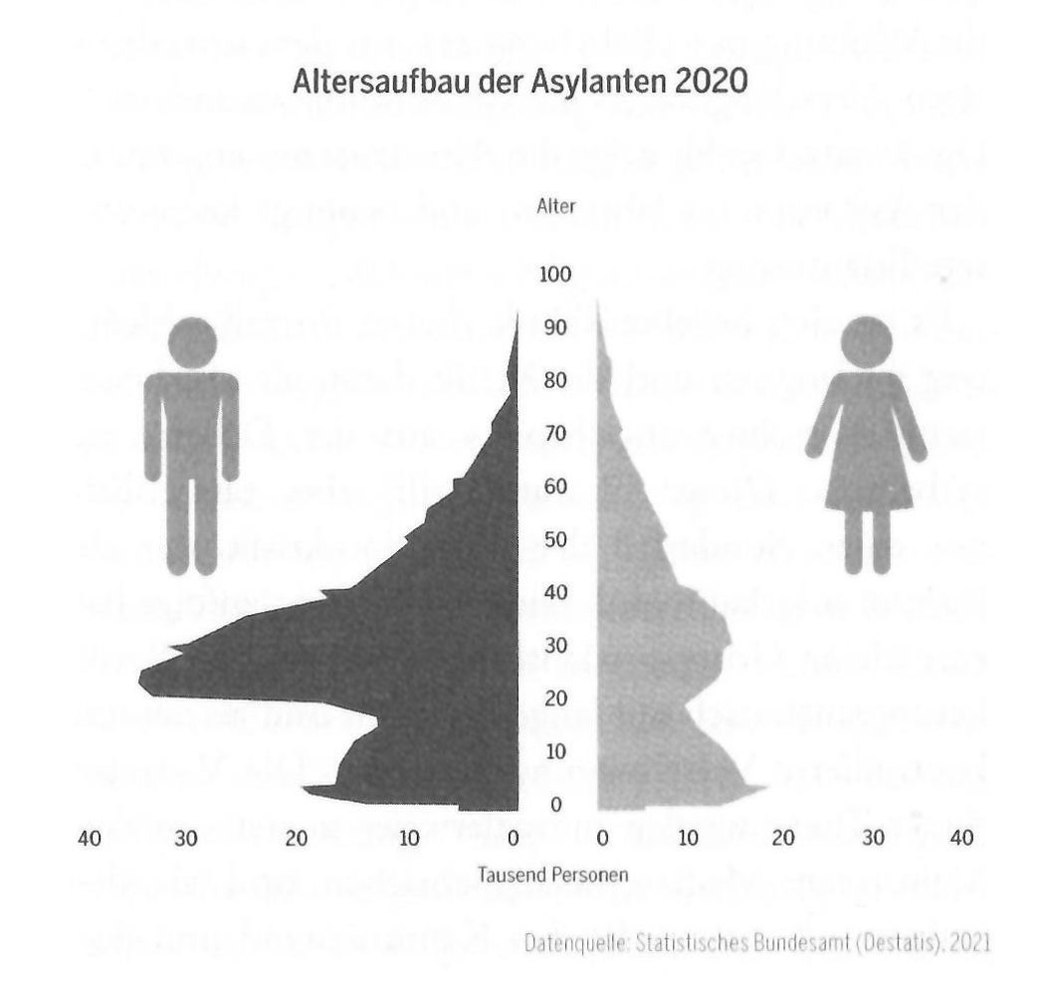

Germans live in a high trust society. As Robert Putnam has written, multiethnic societies become low trust. They suffer from more corruption, criminality, mistrust among citizens and with government indifference, and resistance to authority.
The immigrants form parallel societies in which there are “no go areas.”
Countries that have implemented successful policies against the flood of immigrants include Israel, Hungary, Japan and Korea.
German identity policy
(no notes here)
The culture of guilt and reparations
Germany, like the United States, has had a culture of guilt and a reparations mentality. It is a culture of shame and guilt. Per Sellner, the population needs to once again have faith in itself.
Multiculturalism is the opposite of assimilation. Europeans have become assimilated into Germany – after a couple of generations no one remembers their roots. Today’s non-European immigrants, even after two and three generations, identify more with their co-ethnics than they do with Germans.
The German culture, the leading culture, must regain a positive image of itself. Unless the Germans know who they are, they cannot ask others to assimilate.
Alternative population and identity policies
The naturalization of unassimilated migrants as citizens destroys the social capital and the mutual trust, without which a democracy cannot function.
Identitarian migration policy
Successful assimilation has taken place by the Hugenot French and the Poles out of the Ruhr Valley. When the ethnocultural absorption capacity of a country is overwhelmed through too many immigrants, it fragments the host country, threatens the majority population and reduces the chances that assimilation will ever take place.
The Dunbar number, 150, is the most people that an average person can know. If most of the 150 are other immigrants, he will never assimilate.
The principle of assimilation
(no notes here)
Growing minorities and population groups
Germany’s recognized minorities include the Danes, the Fresians and the Gypsies. Just because you recognize and accommodate existing minorities does not mean you have to import more.
Northeast Asians are model citizens, but they don't assimilate well. They are integrated, but not assimilated. Nonetheless, integrated but not assimilated groups are not the targets of remigration. The Japanese don’t cause problems in Germany.
The lead principle of an of a migration policy that recognizes identity is not just create more parallel societies and to try to reduce the current ones by remigration.
Who loses in population replacement
European and Western immigrants don't represent a threat. Among other things, birthrates are low, just like Germans. There they do not represent a pool for chain migration.
Because of their individualism, they're not going to threaten to loot the state by sucking up social benefits. The Balkan diaspora from East Europe (including us Ukranians) will go back to its homeland when conditions improve.
Two parties of the right, AfD in Germany and the FPÖ of Austria, overwhelmingly expresse a desire to stop Afro Islamic immigration.
Identitarian citizenship
The fundamental principle of identitarian migration politics is assimilation. But assimilation itself is not enough. Not every foreigner that assimilates should be eligible for citizenship.
Birthright citizenship must be done away with. Bahrain, Israel and Liechtenstein offer examples of the right way to do it. You need to live in a country 15 years have an excellent knowledge of the language, both written and spoken and be integrated into the economy. You need have no criminal record. Should have a pride in the land, the flag and the people
Citizenship should be revocable if, after receiving it, somebody shows themselves to be not worthy, not sincere.
The assimilation monitor
A country needs to continually monitor monitor the demographic status quo. As of now, the public data on demography are incomplete, unreliable and often politicized.
An assimilation monitor should not use the unclear concept of a migration background. Instead of that it should look at factors such as the language of everyday speech and identification with the host land.
The monitor should look at what's happening with different population groups. Which are growing, which are not, and which ones are clustered in parallel societies.
Upper limits and quotas
An assimilation monitor would have figures that are useful for making policy. They should look at three factors for every for immigrants of every background.
1. The economic load they impose on the society.
2. The criminal load they impose on society and
3. The cultural load, for example, through Islamization or excessive or clan building and failure to identify with the native society.
Sellner proposes perhaps a lottery system such as imposed by the quota act of 1924 in the United States in order to keep the number of immigrants from any given country or background within a quota.
The intention of this proposal is not to expel all of the migrants from any part of the world. It is simply to bring their numbers in line with what is practical for the country to absorb.
As of 2023. There were about 420,000 Afghans in Germany. It makes sense to allow some immigration, but there has to be a limit.
First example Afghanistan.
The data show that 47.6% of the Afghans in Germany receive welfare payments of some sort. Afghans are eight times as likely to commit crimes than Germans. Danish studies show the same thing about Afghans.
Second example. Lithuania
In 2017 there are around 53,200 Lithuanians. In 1954 was only 7550. Over 60 years, these could be absorbed. Moreover, the Lithuanian birth rate is more or less the same as that of native Germans.
2. Re-migration
Who is affected by remigration question?
As above, policy for each group should be set according to:
1. The economic load they pose on the society.
2. The criminal load they impose on society and
3. The cultural load.
The migrants in question fall into three groups: Asylum seekers, other foreigners without citizenship, and unassimilated citizens.
Group A: asylum-seekers
These are an easy case. Germany has no borders with countries at war, and no obligation to accept asylum seekers. They can be turned back at the borders. If already in the country, it is not difficult to send them out.
The illegal immigration problem should be addressed at Europe’s external borders, mainly the Mediterranean , but also Russia/Belarus/Ukraine. The will to push people back out to sea has been weak, but is growing.
Europe and individual countries need to take stronger measures with the NGOs that promote and transport asylum seekers.
A big question this book is how to figure out where they came from. Though Sellner does not go into it, many destroy their travel documents just so their homeland cannot be identified. His solution is to set up all-purpose Reception Centers and Model Cities, described below.
Group B: Non-citizens
These are illegal immigrants, people who overstay visas, temporary work permits and such. If they are not sent home, they need to go to (I use the German terms)
Ankerzentrum - Reception Center: a temporary shelter, where they are allowed to stay until being sent home or resettled. Sellner implies that most can and will be sent home. Somehow. There are seven in operation in Germany. The objective would be to keep them apart from ordinary German society.
Musterstadt – Model city. The Internet does not offer any clarity on what this is. A subsequent chapter describes it as a community on foreign soil – North Africa – established and financed by Europe, as a home for those who voluntarily leave Germany. The right to remain would depend on good behavior. Those rejected would be sent back to their (acknowledged?) country of origin.
There are a number of different situations.
- ·Lawbreakers can be sent out immediately.
- ·Germany can reduce the social benefits available to noncitizens, making it less attractive stick around.
- ·Benefits could be paid in kind instead of cash, so they could not be sent abroad
- ·Work permits could be allowed to expire
- ·Wages for temporary workers could be held in trust, paid only when the worker leaves the country. Israel and Saudi Arabia do this.
- ·Taxes could be imposed on money transfers to the home country.
- ·The government could impose heavy fines on companies that employ such people
- ·Political activity can be forbidden to noncitizens.
- ·Display of foreign flags, colors and holiday symbols could be forbidden.
All in all, it would be possible to make it less attractive for foreigners to stay in Germany.
Group C: unassimilated citizens
The hardest group to deal with would be citizens who have acquired German citizenship without being assimilated. Their children have birthright citizenship.
You cannot establish a system of second-class citizenship. The solution is to encourage unassimilated citizens to return to the home of their ancestors.
The loss of German citizenship
Citizens with dual nationality can be forced to choose. Some will choose to go home. People who made false declarations to obtain citizenship can be deprived of citizenship. Members of criminal clans and terrorist groups can also be deprived of citizenship.
Incentives to go home
In most cases citizenship cannot be retracted. The objective is to deconstruct the parallel societies.
One alternative is to pay people to renounce their citizenship and go home.
It is possible to set up programs to prepare people for reentry into their ancestral homelands. Once return as agreed, they can be given classes in language, and work skills that will make their reentry easier.
Assimilation pressure from the native culture
The principle of a lead culture – obviously the German culture – needs to replace the policy of guilt and multiculturalism. Germany needs to commit itself to being proud to be German.
A country needs to have pride in its own holidays and feel no obligation to recognize and accommodate outside religions, customs, holidays, dress and such. Sellner sites Hungary’s pledge of commitment to the country, something similar to America’s Pledge of Allegiance.
Foreign government finance of foreign cultures, religious buildings and so on can be forbidden.
The use of foreign languages in everyday speech can be reduced. This reviewer cites the example of the Russian language in Ukraine. Since 2014 most major businesses in Ukraine instruct employees to deal with customers in Ukrainian. It is becoming more awkward to get by with just Russian. The 2010-14 government attempted unsuccessfully to handicap the Ukrainian language. Governments since have been successful discouraging Russian.
Structural social policy
Although all citizens must be subject to the same laws, the law can differentially affect the way people behave. Clans and gangs can be discouraged. The types of crimes they favor can be harshly prosecuted. Working off the books can be prosecuted. Family benefits can be migrant-unfriendly. Foreign ghettos can be recognized as such and heavily policed. Denmark had success with a massive program to finance voluntary return by immigrants.
Deislamization
Islam represents a special problem. Islamic schools can be forbidden. Radical preachers can be prosecuted and expelled.
The difficult group C once again summarized
The goal for group 3 – unassimilated citizens – has to be the long term diminution of parallel societies through assimilation into the majority culture and return migration. In any case the further immigration of problem groups can be sharply reduced by quotas.
3. A quantitative view of re-migration
Numbers are hard to place. There are about 3 ½ million asylum-seekers who should require 5 to 7 years to clear out. The additional 3 to 4 million noncitizen foreigners (the numbers are very fuzzy) may take 15 years. The number of unassimilated citizens is even harder to estimate. It may take 30 years to straighten the situation out.
4. The judicial view of remigration
As things stand there isn’t much legal foundation for remigration. Asylum-seekers come without much difficulty. Noncitizens can easily overstay their visas or work permits. Citizenship, as mentioned above, is difficult to revoke.
The assimilation monitor
Migration advocates claim discrimination when you simply collect data. However, without data, you can't make decisions.
Migration quotas
The United States used migration quotas between 1924 and 1966. It worked. It was based on the country of national origin.
The country has a right to decide who will it do it will admit. There is no obligation to treat all people in the world the same.
Border protection
Border protection is a fundamental sovereign right. Germany is totally surrounded by secure countries. It should have no asylum-seekers at its borders. Any there are should have been turned away when they first entered Europe.
Reforming the asylum system
There is a Geneva protocol on refugees. However, the Germans could refuse to enforce it. This is already being done by the Poles, The Hungarians and the Greeks. The European convention on human rights is also a barrier. It is recognized by Germany. It gives the Afro-Arabian immigrants over the Mediterranean free reign to enter Europe.
The Dublin convention establishes which country will determine the right of asylum-seekers to stay and once that country decides that migrant can't be shoved off to other countries or cannot go to other countries. For a more another decision. In other words, the first country. The season makes a decision for all of the EU. Europe should be united in the desire to protect itself from illegal immigrants. And asylum-seekers. They are, however, not. Poland and Hungary lead the way in protecting themselves by somewhat ignoring the international conventions.
Easily implemented rules
(no notes)
The rights of foreigners
Immigration should be allowed only as long as it is advantageous for the host country and it does not threaten the national identity by law.
The right to citizenship
There are two ways to lose your German citizenship. One is to go into the armed services of a foreign country and the second is through terrorism. There is a need to add a third category, hard-core criminality.
Israel can recind citizenship in the case the person has made a false declaration. Fifteen European Union countries allow the removal of citizenship for disloyalty. In Poland and Spain this is the case even if the person becomes stateless.
In any case we need to do away with birthright citizenship. Force dual citizens to make up their mind whether they're German or something else.
Enticement to re-emigrate.
Germany has been enticing people to leave since Helmut Kohl in the 1980s. They knew that they had too many people. At that point is mostly Turks. Their objective was to reduce the number of Turks by 50%.
Conclusion
Reform is required in all of the legal spheres touching migration. This requires a rethinking of the European Union rights legislation and also the national legislation. It is always the case that the law follows politics and the will of the majority. If it is possible for the millions of people to come into the country, it is also possible for millions of people to leave the country.
5. The logistic and economic sides of re-migration
Fortress Europe: easy and quick to implement
Europe is separated by the Mediterranean as a natural barrier from North Africa. The route through the Balkans leads over the Dardanelles in the Aegean sea. This is what has protected Europe from being overrun before. The northern border, through the white Russian lands, is secured militarily. Drones satellite heat cameras and robots make control fairly easy.
There is no need to build walls. Among other things, you could build a databank of all of the people who are identified as noncitizens and check them out periodically when they come in contact with the authorities. The database at border control would be pretty effective, particularly with the biometrics.
Saudi Arabia and Qatar have very few illegal immigrants. Why? Because they people coming there would have no chance of working. If it were clear that migrants had no chance of working in Germany, the smugglers would lose business and nobody would come.
Germany, Austria and Switzerland could cooperate to prevent people from coming over the Alps. It's a fairly easy border to defend – it has been historically in all of Europe's history.
Migrants could be caught at the border, as they are now, by Hungary and Poland. The neighboring lands, knowing that the migrants could not get past them, would make sure that they did not cause problems by entering in the first place.
From reception centers to model cities
The two concepts are introduced earlier in the document. This is what they are.
Advocates for the migrants so do not want to leave them stateless and you do not want them shoved into places where their lives will be in danger.
The model city cuts this Gordian knot. The (presumably North African) model cities could make contracts with the homelands, to accept the migrants if they have to leave. However, the model city might also offer better work opportunities. There could be incentives to establish business in them.
Europe could redirect a lot of the foreign aid that now goes to Africa to building these model cities. More than that, they can use the aid that they now provide as a lever to compel African countries to agree to the model cities.
Sellner himself writes, "this project may seem utopian and hard to finance. Actually it is the importation and integration of millions of foreign cultures in Europe that is utopian." He was of course right, but the second comes without any advocates.
In 2023 there was €132,054,795 per day given for migrants. That doesn't even include the cost for Ukrainians. That's $52 billion a year.
Model cities are not a concentration camp. People in the model cities or reception centers can leave for their homeland anytime they want. They simply cannot go further into Europe.
Being sent away in great style
It makes financial sense to send people out even at a fair cost in transportation and training for reintegration in their societies, if one is sure that they won't come back. Then a good system of biometric identification and good border controls can assure this. This reviewer notes that the Scandanavian countries are all doing this to some extent.
Neither Civil War nor expulsion
The critics say that this is a mass deportation. No, it's an incentive for people to leave. The measures on timing will be different for categories a, B, and C.
On the other hand, the longer you delay remigration, the greater the chance of the Civil War. When our national government is overrun and gets passed the tipping point along the ethnic breakdown breaking points, then democracy is at an end.
Not expensive, but financially beneficial
The point is here and not that it's cheap, but that it's financially more beneficial to go through with the encouraging people leave that to them not to do so.
In addition, Dutch studies show that Danish and Dutch migration studies show that the replacement migration is a great load on the business and it's better for the society to encourage them migrants to leave then to finance them.
Afro Arabian replacement migration doesn't solve the problem of a lack of skilled workers, instead it makes it worse. You have 50,000 uneducated Africans and Arabs. They represent a drag on the education, health, and other system systems. Their presence drives out the skilled workers among the natives that you want to keep. Here is a news article from the day this review is written.
These skilled people have left, to the United States and Canada, for instance.
The Pew research Center did a survey in Africa and found that more than 50% of the populations of Ghana, Nigeria, Kenya, Senegal, and others wanted to emigrate. Europe simply cannot accept them all.
Such immigrants drive the indigenes out of the schools, swimming pools, parks, and everyplace else. They radically reduce the quality of life for the nativeborn.
The argument that you need to rejuvenate the country through younger blood is contradicted by the experience of Hungary, and Japan. They get along just fine with an aging population without immigrants.
Japan's example shows that innovation is a better alternative than bringing in unqualified migrants. They've done a lot of robotics, automatization, to get around the lack of labor.
The influx of immigrants has reduced the performance in German schools as shown by measures such as the PISA examinations.
The question is not whether we can afford to remigration, to move the immigrants out. The question is whether we can afford not to do it.
6. The moral view of re-migration
This is a question of us and them. Germany now seems to take the position that interests of foreigners take precedence over that of the native Germans.
There are certain part problem groups that take advantage of the benefits of our civilization, but they despise and sometimes purposely damage it.
Unlike the newcomers, we Germans have no place to go. Turks can go home if they want. We Germans have no relief from the suffering the loss of the feeling that we are at home in our own country, our feeling of freedom to express ourselves, our well-being, our security, our language and our national identify and our political self-determination.
The wish of millions of families to find a better situation for themselves is not evil. But on the other hand, there is nothing in our national policy that requires us to help them. We have no moral duty toward them. Instead, we have a moral obligation to our own people and our own country. How many rapes and terrorist attacks does it take to say that the experiment in multiculturalism doesn't work?
Defending Europe's borders and rejecting illegals is not immoral whatsoever, as long as we respect everybody’s humanity, and don't impose senseless suffering upon them.
It is not the African and Arabian migrants’ fault that they can't succeed in our country. It's our own absurd, culturally blind and forgetful obliviousness to historical failures. It is not the migrants’ fault that the migration project does not work. Sellner writes that the migrants are not too lazy, too dumb and too Islamic to participate in German society. What he cannot say is that they for the most part lack the genetic potential to do so.
The guilt for the millions of migrants lies in the fatal migration policy of German politicians. Every country has politicians who gain from migration.
Migrants’ hearts remain tied to their homeland. We see this in the high rate of death tourism, whereby many migrants, after having lived decades in Germany, still want to be buried in their homeland.
Remigration is an emergency brake, a reversal of the failed migration policy. At the end of this big, appropriate project of returning people home we should have a harmonious world and a better life for both the natives and the foreigners who remain among us.
7. Political view of remigration
“It's the demography, stupid” writes Sellner in English. Remigration is the first serious and actual honest trial to meet the demographic challenge and correct things. To settle the deciding question of Europe in the 21st century.I

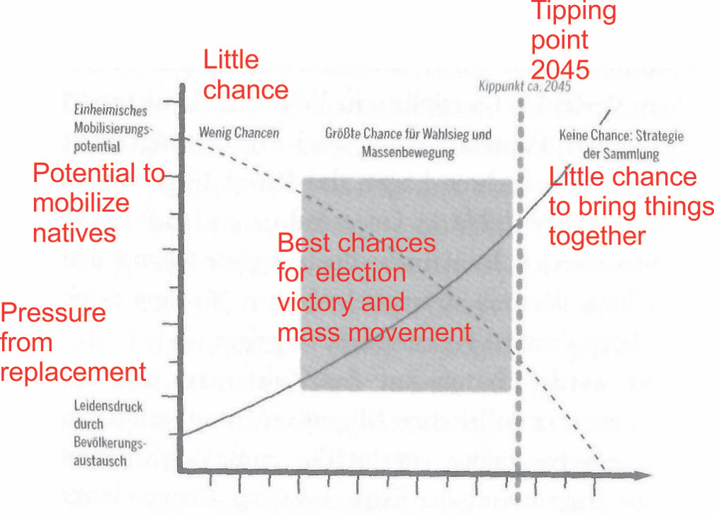

t will require a long-standing legislative majority. Sellner includes a graphic showing that there is a sweet spot for achieving something politically. Where the lines between awareness of the problem rising and falling majorities cross, sometime between now and 2045. While we have enough of a majority population to put something through and enough fear to make it happen.
The demographic replacement represents a massive injustice for the native-born. They lose their claim on material resources and in the end their political self direction. They lose their voice in broad parts of the country. The longer we postpone a remigration politic, the more radical it has to become.
8. Remigration case studies
Afghanistan
Afghans do not assimilate much at all. Sellner counts 419,080 people. Of these a vast majority are not citizens. 30,000 of them were under orders to leave in 2022.
Currently, there are 316,000 asylum-seekers who should be easy to get rid of. Send them home, into reception centers or model cities. They have no right to stay.
42,000 Afghans are in category B – noncitizens in Germany, their under some sort of permission such as a visa. These can also be handled by simply not extending permission if they are not contributing to the society.
Lastly there about 25,000 citizens with Afghan roots. There are a lot of dual citizenships among them, and a lot of affinity with Afghanistan. They can be pushed to decide for one country or the other, and given enticement to leave.
With a hard push, the number of Afghans living in Germany might be reduced to about 2500 by 2040.
Turkey
About 3 million Turks live in Germany. 1.5 million are citizens. About 800,000 of these have only a German passport. Another 1.5 million have an unrestricted right to stay in Germany. This is the legacy of the guestworker programs going back to the 1960s.
The question is raised of whether the Turkish diaspora enriches or impoverishes Germany. A Danish study says that in that country they represent overall a burden.
Turks have a high risk of poverty in Germany. Over one third earn less than 60% of the median German wage. There is a high rate of criminal criminality and a great participation in Islamic parallel societies. There are many unwanted groups such as the gray wolves, who are openly opposed to German society.
Even going to the 800,000 Turks who only have German citizenship, relatively few of them identify with Germany. A questionnaire indicated that 45% of them would really rather go back to their homeland. 60% of them prefer to associate with Turks rather than Germans. Even after many generations, they are not integrated. Policy should encourage them to return home, as Helmut Kohl did 40 years ago. Between 2007 and 2011 hundred 93,000 did that. However long it takes, it is necessary.
Historical examples of remigration
Remigration is no abstract concept. There are many examples throughout world history. In the Eisenhower era in the United States the government ran Operation Wetback to for a mass deportation of illegal Mexican immigrants. They were able to get more than a million to return home. They did this with the help of the Mexican government. Donald Trump is using this as an example.
Another example took place in the Fiji Islands. In the late 19th century, the English colonial power allowed the immigration of a number of Indians. By the late 20th century the Indians pretty much controlled the place. However then the native Fijiians implemented a policy of encouraging the Indians to return home. They are back down to only 26% of the population. The native Fijians have more rights, and they stand on their rights.
Pakistan had 1.7 million illegal Afghans in their country. They successfully encouraged them to leave and go back to Afghanistan.
After the fall of the Ottoman Empire at the end of WWI there was a great population exchange of the minorities of Turks living in Greece and Greeks in Turkey. Over 1.2 million Anatolian Greeks went back to Greece and 400,000 Muslims left Greece for Turkey. The process was not without problems, but it was also without war. There is a similar, more recent example in Cyprus.
There are a couple of reverse examples. In South Africa, since the Blacks have taken over, many whites of left. The government is not very accommodating as they leave, but leave they have. It has not been easy for those who have not.
The same is true in Algeria. Since Algeria separated from France in de Gaulle’s time, many of the people of European roots living there have returned to France itself. They did not get much help from the government but they have done it.
A personal conclusion: there is no alternative to remigration
There is no alternative to remigration. “Wir konnen das schaffen”. German readers will recognize that that's what Angela Merkel said when she allowed the million Muslim migrants into the country beginning 2015. Sellner will say the same in return. We can we can do it. We can get them out. And we must, if it is going to be our country.
============
That’s the end of the review, or rather, short summary of the book. It is valuable as a reference as the United States frames its plans for dealing with its own immigrant problem.

