City, Animal, Vegetable, or Fruit
ИРОЛОКДК
IROLEOCDC

You can rearrange these eight letters to make a well-known Russian word. Or nine letters to make an English word. What is it? An animal, vegetable, fruit, or a city?

Thank you for the answer yes that’s right. Crocodile. This is a sample item from an intelligence test. Intelligence is something that people are scared to talk about anymore, but everybody has it, and everybody certainly knows it exists.

How you answer 20 or 30 questions like this is a pretty good indication of your intelligence. Intelligence is highly correlated with success in life. Lawyers have an average IQ of about 120; janitors less than 90. Very significantly, it doesn't necessarily have anything to do with language. Questions like the following (called Raven Progressive Matrices , dating from the 1930s) require no knowledge of either language or mathematics, yet performance on the test correlates very highly with performance on tests involving language and math.
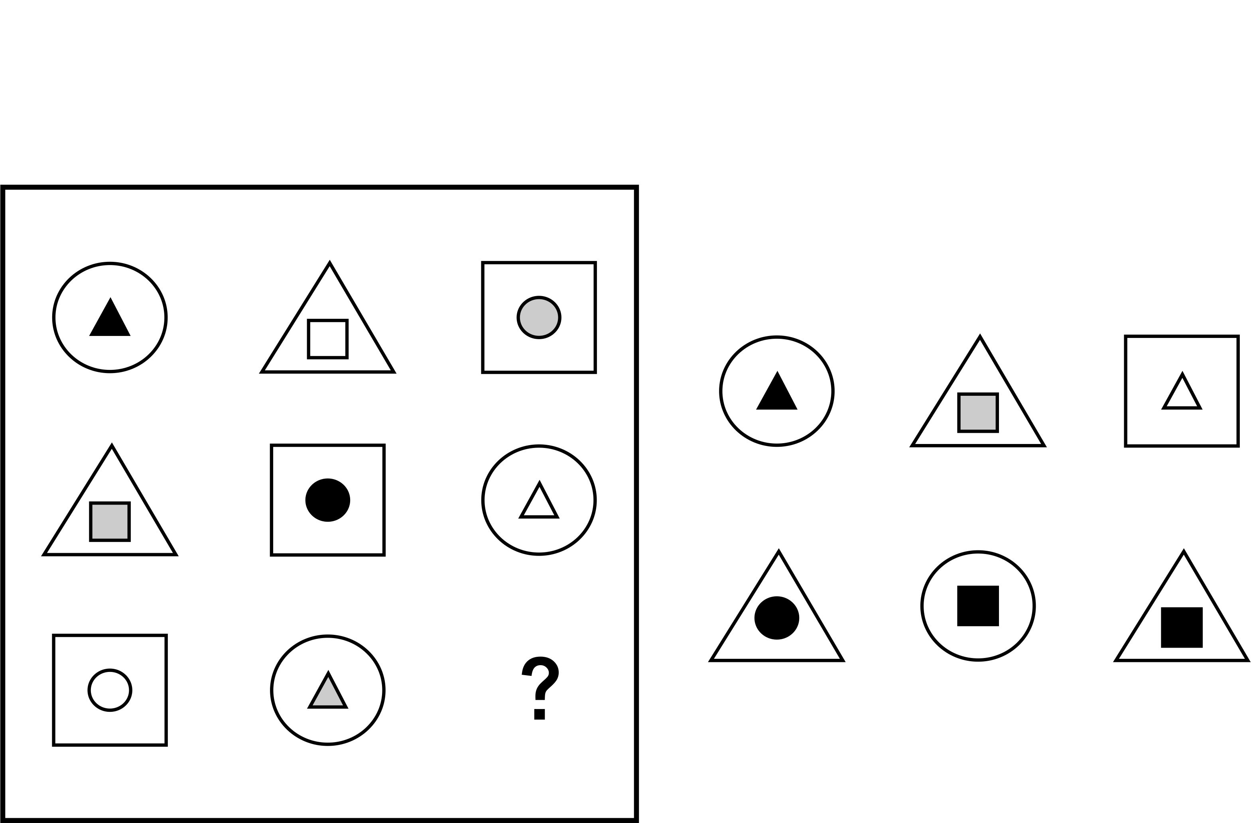

There are a number of intelligence tests available on the Internet. Here's a simple one. Doesn't tell you your IQ, but gives you an idea of the kinds of questions that make up a test.

Intelligence is heritable. The genes you got from your mother and father are responsible for somewhere up to 80% of your intelligence. Of course the genes they carry represent many generations back, and you may be smarter or dumber than your parents. People have wished very hard that this was not true. They have been trying for eighty years to help people improve their IQs. Nothing works. A person can be successful by making good use of the IQ they have, but changing IQ itself doesn’t work.

Race and ethnicity are also inherited. If you have Chinese parents, you will be Chinese. Putting these facts together, you come to the conclusion that different races and ethnicities might have different average levels of intelligence. In fact they do.

This is nothing new. The Greeks knew it. The very first statistician, 100 years ago, Spearman, used intelligence to invent the science of statistics. In World War I, the United States Army was regularly using intelligence tests to choose officers. Since the 1960s people have known the average intelligences of the major ethnic groups within the United States. Here on this slide are the average intelligences. I’ll tell you the groups. They include us white Americans. We invented the tests we put ourselves in the middle at 100. The other groups include African-Americans, European Jews , Chinese and Japanese, American Indians and Hispanics.

Average Intelligences of Major Ethnic Groups in the United States (Wikipedia)
85 90 100
90 105 115

You’ve heard about the famous bell curve of intelligence distribution. Here is the bell curve for us white people. Remember, this isn’t something anybody “found out.” It’s how IQ is defined.

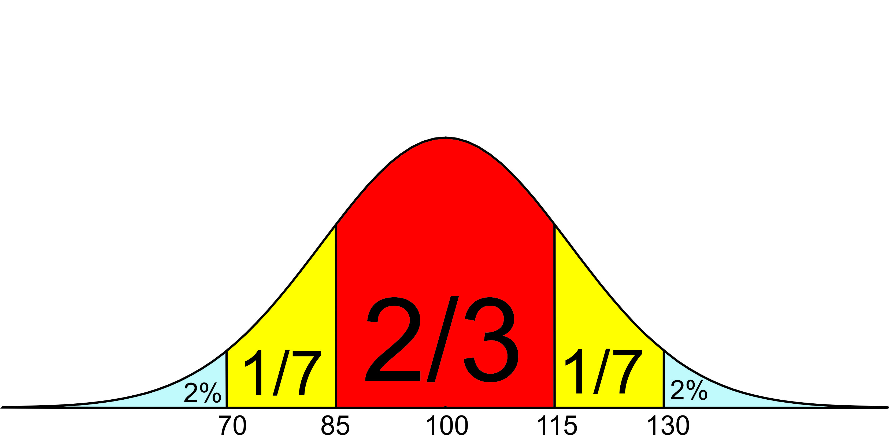

2/3 are in the middle. 1/6 of the white population has intelligence above 115; another 1/6 below 85. Here at the ends are some really smart people, and some who really aren’t. This seventh is as smart as lawyers; these are dumber than the average janitor.

I mentioned that there is one American population with an average IQ of 115. There are only 1/30 as many of them as us ordinary white people, but they are still very noticeable. One in six of them have IQs above 130, compared to 2% of us ordinary white people. Lots of them are doctors, lawyers, and university professors. At the IQ level of 155 there are about equal numbers of them as ordinary white people.

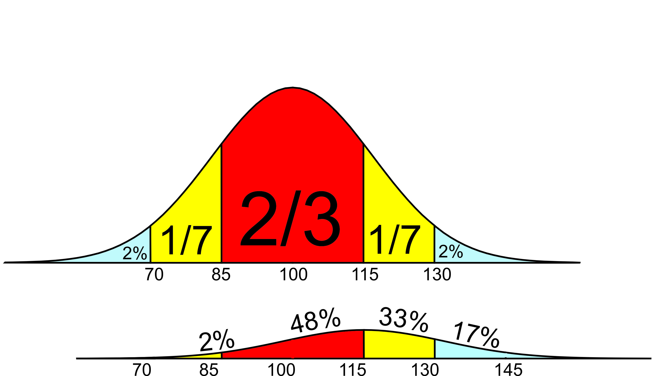

And, needless to say, they have been the object of jealosy and prejudice throughout history. Ordinary white people were jealous and pulled them down. That’s why they came to America.

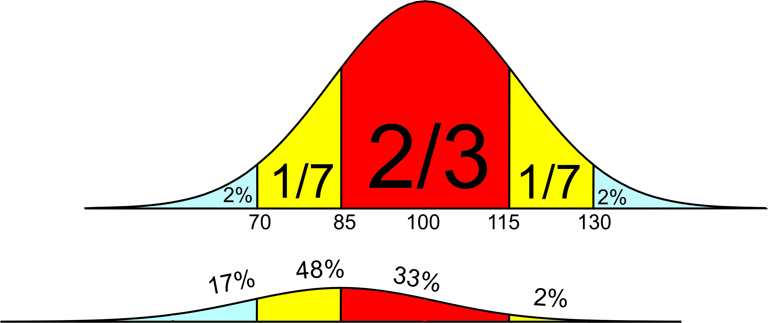

I also mentioned that there are populations with IQs of 85 and 90. The same thing happens in reverse with them. In general white people have more education, earn more money, enjoy more prestige – everything – than these subpopulations. But these folks don’t see it that way. Human beings seldom blame their problems on themselves, especially not if the problem is just plain lack of brains. They blame the most convenient target – in this case, the white man. They want to pull the white man down. However, you see that the bell curve is quite wide. I know of people of every race who are smarter than me.

We cannot afford to be prejudiced against people because of their race or background. It isn’t fair, and we would make mistakes. We, as individuals, must look at the individual. Thank goodness we generally do. There have been famous Americans of every ethnicity. George Washington chose a free black man to survey the nation’s capital. Thomas Sowell wrote my favorite econ textbook. There are famous Dutch too – I read a gripping book entitled “Infidel” by and about Ayaan Hirsi Ali, a Dutch woman born in Somalia. That is, used to be Dutch. Unfortunately, she told the truth about Somalis. The Dutch kicked her out and she’s now an American.

Now comes the second part of the problem. Governments cannot look at individuals. They have to apply the same rules everybody.

The Dutch traditionally take care of each other. They assume their fellow citizens are smart and hard-working people. Anybody can have bad luck in this life, and the government takes care of people who have bad luck with their jobs and their health. The assumption is that when they go back to work, they will pay taxes to support other Dutch people in trouble.

This kind of socialism worked fairly well when it was just Dutch in Holland, Swedes in Sweden and Germans in Germany. But these countries have invited large numbers of immigrants. Evo told us last month how it works – one comes, and eventually brings his whole family. These immigrants are not nearly as smart, on the average, as white people. Even if they want an education, most can’t handle it. Even if they want to work, few of them have the skills for high-paying jobs. They tend to live together, in poor parts of the cities, where they don’t have work. They could blame themselves for being dim-witted, or blame the evil white man for their situation. Guess who they choose? And, they are becoming more numerous. They bring their families, and they have lots of children. The native white people, who have more ability to earn money, pay for it. Any chance they will start to become angry and prejudiced? They are – nationalist parties are rising in every European nation.

Western Europe is in a fix. They can’t send immigrants home, they can’t make them any smarter, and even job training programs don’t work. Official Europe works very hard to simply ignore the situation. Crime reports don’t mention Muslim names. National government stop keeping statistics. People who tell the truth – Ayann Hirsi Ali and me in this speech – are accused of hate crimes and lose their jobs and citizenship. Everybody please, just shut up!

I’m saying this to you Ukrainians. Every country has a right to decide how many, and what kind of immigrants they will accept. Right now Ukraine doesn’t want any. Europe wants to press you to become like them and open the doors. It is poison. Nobody will blame you if you do like the Japanese, the Chinese and the Baltic states and keep immigrants out. If you let them in you will experience the same problems as Europe and the USA. They will become prejudiced against you for being white. So – avoid prejudice, avoid immigrants. Stay out of Europe.

