Dear Angele and Jim,

I haven't put together a full account of my trip to the Amazon. My journals run to 20 pages and don't start to get into the most interesting part, the analysis.

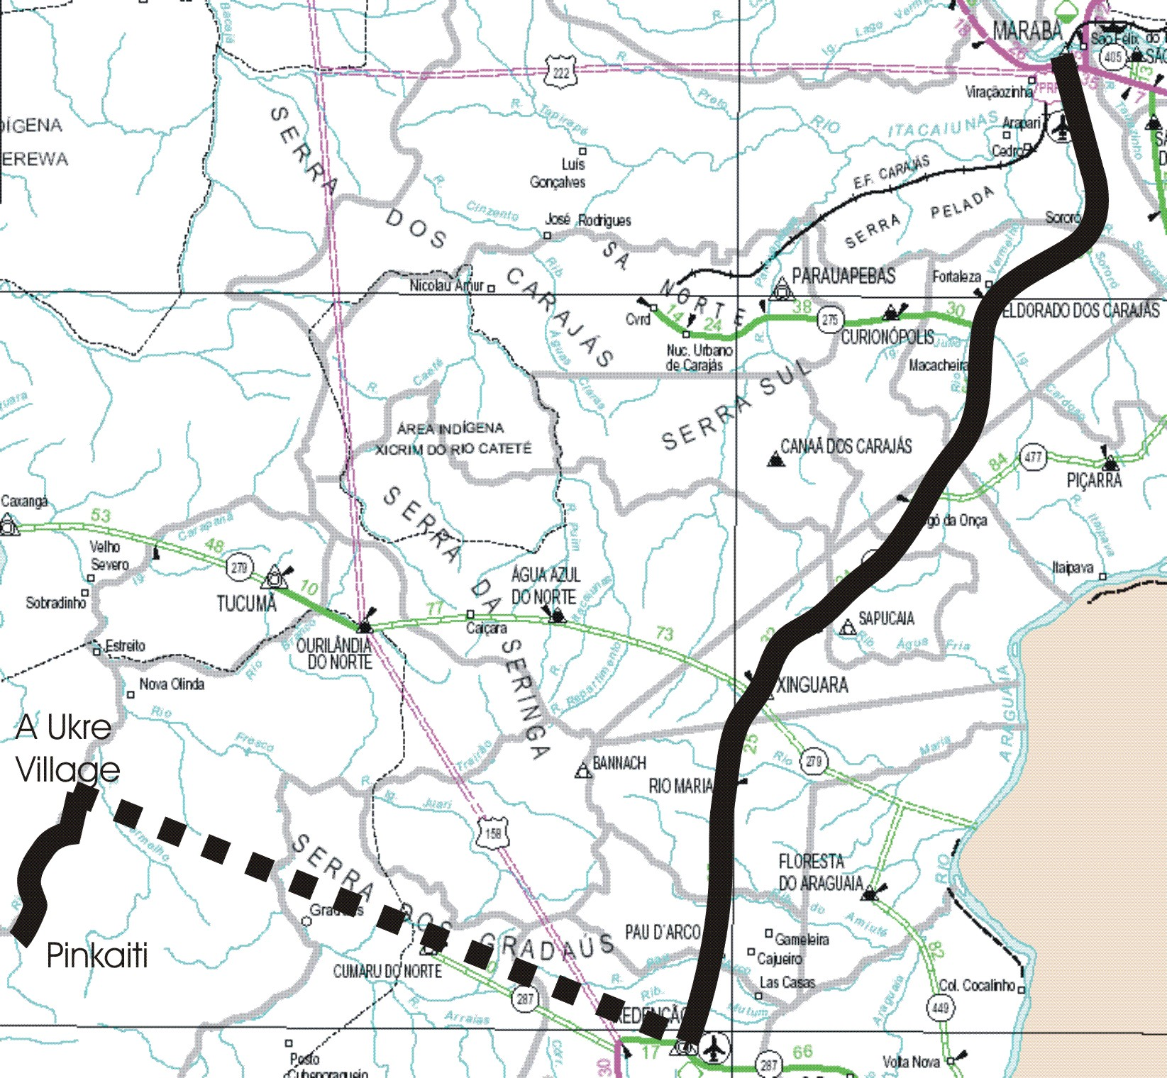


Here's a map of our route through the south of the state of Pará. Fly to Marabá, which you should be able to locate on a map, arriving June 19. Stay there Sat-Sun-Mon then Tue drive seven hours south to Redenção, which you may not find. Finally, on Fri fly 100 miles or so into a dirt airstrip at U Akre. Spend the night then travel 15km upriver by dugout canoe to the Pinkaití research station, where we stayed for two weeks. Unwind the trip with three nights in A Ukre, then Redenção, and finally out of Marabá.

Redenção is the frontier. Imagine a town named Redemption, Arizona, with dusty, unpaved streets, hombres with big hats, jeans, and gaudy buckles. Picture bullet holes in buildings along the main street from a shootout a couple of years ago during the audacious simultaneous holdup of all three banks.

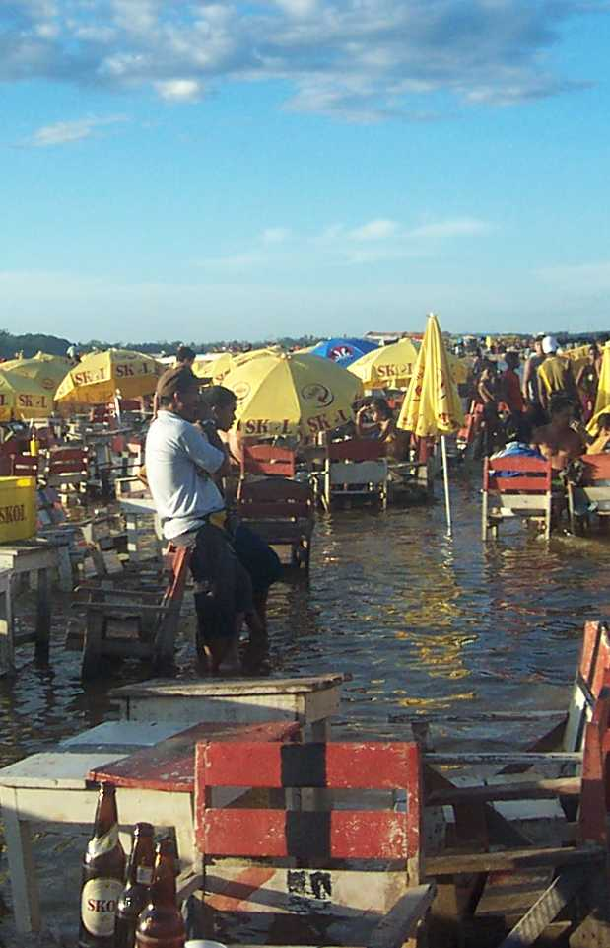
Marabá is a bit more civilized. It's where the cowboys go for fun. Here's a picture of an 18-year-old student getting familiar with Miss Kitty. It also has the most fantastic river beach I've ever seen. Fine sand, no waves and no tide. The concessionaires -- more likely just entrepreneurs -- set tables and chairs right in the water and brought you cold beer. Signs of the beer are everywhere in this picture. Bottles in the foreground, beer-branded umbrellas, empty cases. It has a high enough water content, and is cheap enough, that you can drink the stuff all day with no ill effect.

It is called Praia do Tucunaré, after the best eating fish in the river, the peacock bass. It is simply prepared, no sauces and not even lemon, but still delicious. A welcome change from the churrasco, or barbecue, that is the staple restaurant menu.

Now that I've sucked you into the discussion with teasers on sex and leisure, on to the more serious stuff. To express the problems of the Amazon in a single word, one would probably choose "cows." Land titles are notoriously iffy in Brazil. The powers that be divvy up state-owned land among friends. To secure the title the new owners have to put it to productive use. Think they have to any how -- again, the laws are fuzzy, contradictory, and uncertain in their application.

The quickest thing to do is to sell any lumber for which there is a market, burn the rest, throw grass seed on the ashes and run cattle when the seed sprouts. It sure as hell makes it hard to confuse a ranch with a rainforest. It is almost risk-free and makes a dollar or so profit per acre.

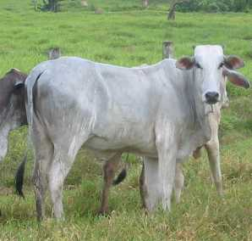
Cebu cattle do well in the tropics but they don't make very tender beef. Northern churrascos, unlike those of Buenos Aires, for example, feature well-cooked, well-seasoned meat. The main attraction is that they are cheap.
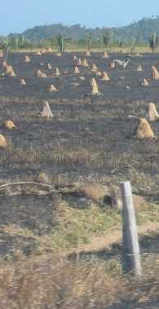
The annual loss of rainforest is dramatic. Tens, maybe hundreds of thousands of hectares. And for what? So a few people, who wouldn't receive land unless they already had some money and connections, can get title, patent the land by using it for a while, and flip it for a profit. All the while the meager fertility of the land is being diminished by this unaccustomed usage. The primary beneficiaries seem to be the termites. God knows what they eat, but termite mounds abound in the pastures.

So who owns the rainforest in the first place? Large private holders have some, the government owns quite a bit, and the Indians have quite a bit. The 1973 Law of the Indian roughly defined reservations for the remaining tribal Indians, at that time still far from civilization. The allocations were generous. About 2/3 of all protected lands in the Amazon are in indigenous reserves. The Kayapó, with whom we stayed, have 11 million hectares, about 42,000 square miles, the size of Virginia. There are about 5,000 of them.

As with all things Brazilian, there are questions with regard to what they own and who does the owning. What they own is everything "above the subsoil." The Brazilian government owns the rest. Bottom line is that the land is theirs to use, sort of, but not theirs to sell. Indians are not legally persons. The Law of the Indian defines them as minors. They cannot enter into contracts, vote, get passports, etc. To do business they must form a "pessoa juridica." This is a non-natural person, a construct similar to a trust or corporation in American law.

A huge gulf separates the definition and the application of the law. The Kayapó could never depend on the government to defend the integrity of their territory against garimperhos, the illegal gold miners, or madereros, wildcat loggers. A few judicious and widely publicized killings of trespassers served as a warning that the Kayapó would defend their rights. The Kayapó have become pretty savvy about dressing up in war paint and feathers and declaiming abuses for the TV cameras. They have garnered a lot of support from NGOs and rock stars (Sting, Harrison Ford...) in defending their rights.

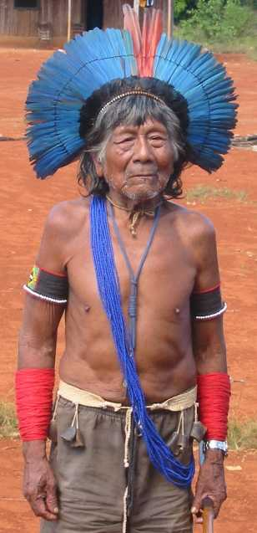
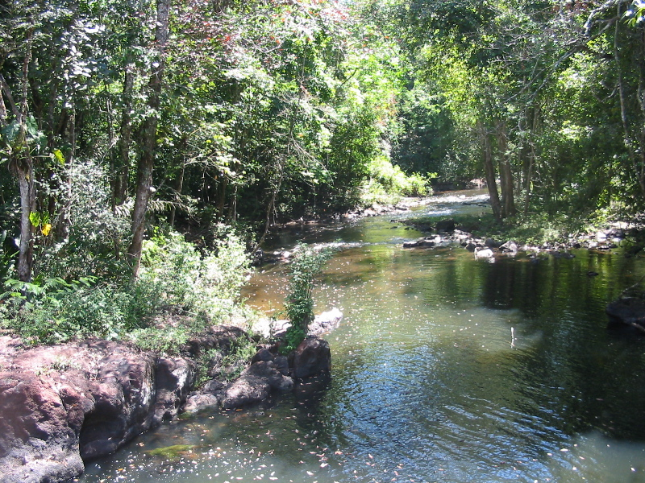
A confrontation over the proposed Altamira dam, which would have flooded Kayapó territory, caused the World Bank to back off funding the dam and made a global celebrity out of chief Payakan of the A Ukre village we visited, and whose father Chiriki, shown here all duded up for a festival, is still a fixture in the village.

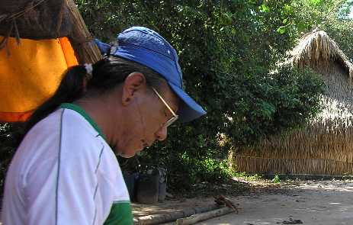
Subsoil rights are a fungible concept. In the roaring '90s the Kayapó let loggers cream the mahogany out of their reserve. The village of Gorotire (close to where Gradaús appears on the map above) cut a deal with invading gold miners. For a slice of the take they allowed them to continue work. The result was a valley totally ruined by Placer mining and the people afflicted by poisoning from the mercury used in mining. The profits allowed some young bucks to live in high style in the town of Redenção and resulted in a great deal of dissention among the highly egalitarian Kayapó. Payakan, the international star, lost his chiefdom, was convicted in absentia of rape, and now lives alone on the isolated Rio Vermelho.

The five Kayapó professors at Pinkaití are leading men from A Ukre. Conservation International uses them because they speak Portuguese, know the forest, and are resourceful and reliable men. Letting them show us the forests was an absolute delight. They know the trails intimately. They have an instinctive sense of direction. They know the animals by their tracks, their sounds and their smells. They know the hundreds of species of trees, vines and plants by their seasons and uses. There is a vine that smells like almond; another that is full of sweet, clear water that needs only be cut and drunk. Yet another will relieve a sore throat when you wrap the bark around your neck. You can keep fish fresh as you carry it over long distances by laying it in a palm frond and braiding the ends together over a piece of bark that serves as a belt.

As no single picture can convey the grandeur of the rainforest, I've chosen this kind of Turner landscape for its own beauty. The story it tells is of a somewhat broken triple canopy, a less than totally flat landscape on the southern edge of the Amazon shield, and green broadleaf foliage everywhere.

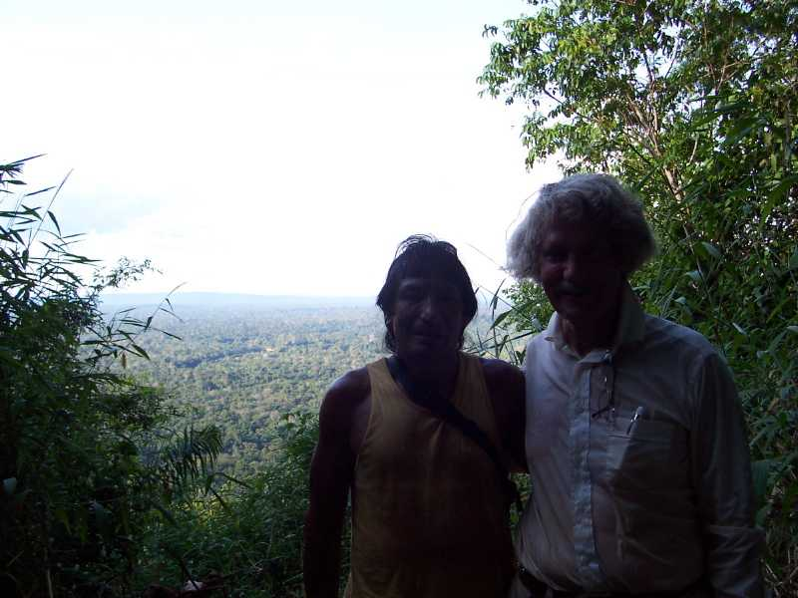
This is a paragraph to brag a bit. I've kept my eyes open and my body in shape for six decades. The Kayapó anointed me Cangraré, after some warrior of bygone years, and considered me to be the chief of the white tribe. Granted a head start by my generous endowment of years, I earned their respect by knowing where I was in the forest -- watching the position of the sun, moon and Southern Cross, following contours, etc. -- and being in a physical condition almost equal to theirs and markedly better than that of the 20-somethings on our trip. Ireo and I were the first to the top of the mountain from which this picture of the two of us was taken. The 18-year-old guy made it with us, the 24-year-old straggled in 15 minutes later and the 20-year-old quit and headed back to camp. One girl had stayed in camp; the other three summited closely after Ireo and me.

By speaking adequate Portuguese I could swap life stories with the warriors. Though Janet, our anthropologist leader, learned more in an academic sense, I feel I acquired a feel for the men's house on a par with anybody's. Though most of our time was spent joking, they were full of questions about my life and I learned quite a bit about theirs. I have a sense that the grass is always greener. Though these guys stay in great physical shape, live in a paradise, get all the sex they want and have lots of kids, they envy me for my material possessions. They didn't ask me if I envied them, though it seems to me to be a very reasonable question.

The Kayapó are strong in standing up for their rights. They need a school. The Ministry of Education would build them one. What kind? Oh, the regular. Four upright poles and a thatched roof. No deal! The Kayapó deserve a school with a concrete slab floor, solid walls and a metal roof. Rather than cave to the Ministry's insufficient offering, they have gone without a school for five years.

This vignette captures the essence of the nation. They are strong in standing up for their rights but rather weaker in recognizing their own self-interest. They don't know it, and one could wonder how they could. They are a stone-age people entering directly into the 21st Century. This is the dilemma of Kayapó education, and I (remember) am a doctoral candidate in education. What is to be done?

First is the moral issue. What right have I, or we the first world, to tell the Kayapó what to do? The dogmas of our age, cultural relativism and such, instruct us that it is counterproductive, even evil, to lift up the white man's burden. Leave it to them!

But we see where that leads. Mahogany stripping, gold mines, mercury poisoning and suchnot. These folk are so naïve that they surely need somebody to tell them what's what. But who? How?

The Kayapó will become acculturated. There is no way around it. First of a couple more vignettes: I have heard there will be forro (pr. fo-ho) dancing our first night back in A Ukre. I hear the music in the moonless night, but see nothing. I follow the music. There, in the abandoned body shop brazil nut processing plant are a bunch of kids dancing. Unmarried kids. In a society which still believes that menstruation is brought on by intercourse, and marriage by selecting among the likely fathers of one's first child, that means young kids. Pre-adolescent. And there they are, dancing to Brazilian music, to a boom-box, in the dark, because there is neither electricity nor radio.

Second vignette. The warriors with whom I travel daily to the forest, Ukaruru, Ireo, Tiago, Bastion and Ngepre, are concerned that the younger generation is not learning the ways of the forest. They spend their time in the village, playing battery-powered video games. Even the boomer generation does not know the true forest, the uses of all the vines and such, as well as Bastion and the few other sexagenarians.

More and more of the men learn Portuguese. The women understand it but will not speak it. They are still fully occupied with raising the families they begin at age 12 or 13. But Tiago, the best educated, says his daughters will get an education before they marry. Hmmm. Where does this lead?

A note about Tiago. He is the guy they sent to town to learn how to maintain the fresh-water well. He is the one who is negotiating about schools. He worked a couple of years in the big city for FUNAI, the bureau of Indian affairs. He is not viewed as being in line to be chief because they are not sure they trust him, but.... he is the guy who understands how things get done in Brazilian society. What will his role be?

Now we round the corner to education. In the Kayapó world it has meant going out into the forest at about eight years of age to learn all of the things of the forest, the trails and the trees, and most importantly, how to hunt and fish. In our world that assumes a classroom, a teacher, a curriculum and some teaching resources such as textbooks. Two different views. Which is right? Which will be valuable to kids being born today?

That's the issue of my final paper. I'm well into some good Portuguese wines and ready to call it a night. So I'll end the dissertation here and let you wait for the rest of the story. Which will probably be my paper, what in hell should we do?

[two years later I add the paper, below]
Introduction

The Kayapó are making their accommodation to Brazilian society late in history. Whites (kuben) worked their way only slowly into the Kayapó's homeland in the cerrado (savanna) and forests of the Brazilian states of Pará, Matto Grosso and Tocantins. The Kayapó's reputation for killing intruders made fortune hunters tend to look elsewhere. A lack of ferocity and the misfortune of living in the paths of an expanding Brazilian civilization long ago brought most of their Indian brethren to terms with the national society.

Terms of accommodation were overwhelmingly dictated by the Brazilians. In the sixteenth and seventeenth centuries the Portuguese simply enslaved the Indians. The Jesuits gradually brought the practice to an end, noting that Christianity was a hard sell among enslaved peoples. Thereafter and through the twentieth century Indians continued to be brought under the "protection" of the white man, supposedly for their education and betterment, a situation which again often meant labor for minimal wages at tasks not of their choosing.

Over the past few decades the situation has improved. The Indians' rights to their own reservations and their land is written into the Brazilian constitution. The result is that while Brazil counts only about 200,000 tribal Indians, a mere ½ of one percent of Native Americans in the hemisphere, those few groups are today quite well endowed with land and have several government bureaucracies to serve them.

Indians continue to suffer from the gap between de jure and de facto law in Brazilian society. The Kayapó have however grown resourceful in using the law and public opinion to defend their interests. For the first time in history there are groups of Indians who have title to something well-defined and worth defending, and the tools and connections to mount a defense. This moves the focus of the issue to a new set of questions. What are the Kayapó's long-term prospects? What are their long-term interests? Do they know their long-term interests? And, most significantly, what can they do for current income to support their material needs without invading the corpus of their forest patrimony?

The question bears on three interwoven themes: time, money and education. For Indians, the equation between time and money is a new thing. The nomadic Kayapó, with minimal material culture, historically lacked the realization that structures and machinery have to be maintained over time. They had no history of trading time at labor for money, nor of investing over time in return for interest income.

Indians' initial exposures to a money society are fairly uniformly disastrous. Kaj Århem noted that Indians of the Colombian Amazon tend to spend what money they get, acquiring things they do not need and cannot maintain, and contract debts they cannot service. The history is repeated throughout the Americas. Zimmerman et. al. (2001) report that the Kayapó realized millions of dollars liquidating their prime mahogany and permitting gold mining in the 1990s, and have little left to show for it today.

Here are the elements of the dilemma. The Brazilian Constitution and the Law of the Indian grant the Indians the right to self-determination. It is only just, and could not be otherwise in today's rights-conscious world. At the same time, it is widely observed that indigenous American peoples have difficulty coping with aspects of the modern world such as alcohol, money and individualism. Brazilian law accords them a status of judicial incompetence similar to that of minor children. What kinds of lives will or should today's indigenous peoples lead, what education do they need to prepare for these lives, and what right do any outsiders, conservationists, governmental or whatever, have to influence indigenous education?

External Contacts and Essential Expenditures

Kayapó Chief Rop Ni observed in 1976 that the time had passed when the Kayapó could maintain a totally autonomous existence. The villagers of A'Ukre depend on the government to maintain their airstrip, their deep water well and their septic system, complete with its flush toilets. They have eased their traditional hunting and gathering labors through the acquisition of shotguns, outboard motors, chain saws and fishing tackle, their paths through the forest with manufactured shoes, and their treks with sleeping bags, tents, mosquito nets, flashlights and other western paraphernalia. They have generated a demand for gasoline and batteries. As a consequence, the Kayapó's attentions are focused on acquiring these goods by trade, and increasingly, simply acquiring the cash to buy them.

The 5,000 people of the 16 villages of the Kayapó nation are closely related. They use air taxi services and an airplane bought with mahogany money to visit one another. They are linked by a CB radio network powered by solar cells connected to automotive batteries. Whoever paid for it -- the cost was probably not great -- radio has become indispensable. Radio has evident imperfections as well. It can handle only one conversation at a time, it is absolutely not private, and requires all speakers to be at their radios at the same time. There will be a market for telephones or VOIP connections.

Maintaining airplanes, radios, and even chainsaws and outboard motors requires more training, reference materials and tools than the Kayapó possess. Their dependence on kuben society for these services exacerbates their need for cash income. Negotiating and contracting for complex and expensive services such as aircraft maintenance requires a certain level of sophistication in addition to knowledge of Portuguese and basic accounting.

A mere inventory of material wants understates the interaction with and dependence of the Kayapó upon Brazilian society. The Kayapó recognize both Western and traditional branches of medicine. Shamans still treat some ailments, but they look more and more to Western medicine. FUNASA (Fundação Nacional de Saúde) has established an infirmary at the village of A'Ukre. Angela, the resident nurse, maintains health records and growth charts of all the village children and treats common infectious diseases. She arranges air transportation to send the more seriously ill to hospitals, the closest being about 100km distant in Ourilandia do Norte. The Kayapó have an increasing appreciation for the value of eyeglasses, insect repellants and over-the-counter medicines.

The Kayapó are in the minority among Brazilian indigenous people in having no school of any sort. Accounts of Kayapó education under FUNAI prior to 1991 are vague. In any case little residual effect is noticeable today. The probable reasons that they don't have a school today are complex. There is an anecdote to the effect that the elders of A'Ukre rejected an offer to set up a school in the abandoned Body Shop / schoolhouse building, demanding instead a new and better building. Such a stance would have been in character, but it is not even clear with whom they would have been negotiating.

They want a school. Most of the elders with whom we worked signed the plea that has been posted on the Internet since 2002. Dealing with educators should and will become an essential outside contact for the Kayapó. The evidence is that they will need to be strong advocates of their own interests as they deal with the educational bureaucracies.

Kayapó Sources of Income

The Kayapó control a vast resource in their virgin rainforest, 11 million hectares, the size of the State of Virginia. The income potential represented by their labor force of 2,000 untrained adults is insignificant by comparison.

They must meet their cash needs by one means or the other. The essential questions are how to derive an ongoing income from their rainforest without destroying it, or how to increase the value of their labor. Otherwise they are likely to fall back on the third and tragic option, far too commonly followed by indigenous peoples, squandering the patrimony in return for a temporary influx of cash and leaving future generations to fend for themselves. A catalog of the major income possibilities includes:
Labor
- Handicrafts: The Kayapó sell bows and arrows, war clubs and beadwork to visitors, and have some limited outlets in the cities. Production and marketing of handicrafts could benefit by better organization and connection with markets. There is however a limited market for tourist items and many other Indian tribes make comparable artifacts.
- Services: Kayapó genipap body painting is quite unique. There is again a limited market and it is a service that must be delivered in person.
- Conservation Organizations: Conservation International employs a significant fraction of the elders of A'Ukre village as associates in their Pinkaití research center. There is potential here. A tiny fraction of the resources of NGOs, environmental organizations and environmentally engaged individuals would satisfy the Kayapó's income needs.
Sustainable forestry income
- Brazil nut collection: Brazil nuts remain abundant despite widespread logging. The world market is weak and getting nuts or oil to market from remote corners of the reservation is prohibitively expensive.
- Permits and Fees: The Kayapó receive a per capita stipend from visitors to the Pinkaití research station and a stipulated income for the use of the 8,100 hectare (ca. 32 square mile) station. Increasing the number of visitors could significantly offset their income needs.
Attractive but unproven suggestions
- Ecotourism, including sport fishing: Such ventures would require the development of significant infrastructure and would expose the Kayapó to potentially detrimental outside influences.
- Harvesting or researching medicinal plants: Though much is made of the medicinal value of rainforest species, few are proven and there are no markets.
Unsustainable Activities
- Logging: Most mature mahogany has already been cut; it will be at least a generation before it can be harvested again. Cutting what remains in Pinkaití and in remote recesses of the reserve would end the relationship with Conservation International. Logging lower value species would very likely have to ruin the forest to be economically feasible.
- Agriculture: The Kayapó are not and do not want to become ranchers or farmers. Either activity would require clearing some forest and represent a radical change in their culture.
- Gold mining: Mining on the Rio Fresco in the Gorotire territory was a disaster. It converted the valley into a wasteland of sand dunes and stagnant pools that will take decades or centuries for the forest to reclaim. Mercury poisoned the fish, the groundwater, and the Kayapó themselves.

Income from sustainable activities may runs into the tens of thousands of dollars per year, that from unsustainable activities could easily be millions. The challenges for the Kayapó are stark. They need to invent ways to earn more sustainable income. If, in the worst case, they are forced to realize unsustainable income from the forest, it is essential that they invest the proceeds to provide returns over time. They will need education in either case. The Kayapó have to become sophisticated in trading time for money and letting money work over time or they will become the slaves that Sting so fears.

The State of Indigenous Education in Brazil

Until recent decades Brazilian applied a mainstream view of education to its Indians. All Brazilians need a primary education to learn to read and write Portuguese, to do basic arithmetic, and to know the fundamentals of Brazilian culture and government. Promising students need the opportunity to advance to secondary education, which involves more advanced work in these subjects, and broader exposure to sciences and the world outside of Brazil. Those with the ability and desire should have the opportunity to go from secondary into universities.

Brazil's 1988 constitution reflected the world, and more specifically the American multicultural zeitgeist. "The State shall protect expressions of popular, Indian and Afro-Brazilian cultures..." and "...Indian communities shall be ensured the use of their native tongues and their own learning methods." Articles 78 and 79 of the 1996 Lei De Diretrizes E Bases da Educação Nacional effectively give Indian communities control over their own education. This implied autonomy is a major theme of most of the addresses to the 1994 Congresso de Leiture do Brasil included in "Leiture e Escrita no Brasil." The various authors at once examine what autonomy might mean in theory and deplore the fact that in practice few Brazilian states have implemented much of anything. Tocantins, a recognized leader, declares "A conquista da autonomia" (the conquest of autonomy) as a goal, and provides a program to educate native teachers.

The Lei de Diretrizes e Bases da Educação Nacional defines Indian rights in education. However, since an executive decree transferred responsibility from FUNAI to MEC in 1991, indigenous education appears to have fallen into limbo. The competent bureaucracy remains within the Ministry of Education (MEC) but responsibility lies with the various state educational bureaucracies. As the law is not very specific about what needs to be done and who needs to do it, not much is happening.

The noble turns of speech in the constitution and the laws aside, it is unclear what indigenous education should or could be. The laws do not deal with the practical limitations. Education programs are expensive to develop. That is why most societies centralize the effort at national and state levels. One criticism of American education is that local school boards, serving only tens of thousands of students, don't have funds to do an adequate job. Where does that leave the Kayapó, with 5,000 people and no tax base?

Implementing a complete program for Kayapó education would be vastly more complex than a mere school district. There is no written language. It is unclear what literacy even would mean if it were not in Portuguese. The written materials that exist regarding Kayapó history, myths and culture are written by outsiders in outside languages. Even if there were a written language, which might be developed by philanthropists such as the Sumner Institute of Linguistics, the economics of publishing would make it cost-prohibitive to translate textbooks into Kayapó. There are few examples in history of a written language being adopted de novo. The most notable, Vietnamese, involved a population of tens of millions and a society with a basis of literacy in Chinese ideograms. Written Hawaiian and Maori are struggling because they have no natural role within their English-speaking societies. For the Kayapó, an attempt at native-language education would be a conceit standing in the way rather than a path to education.

Despite the emotional attractiveness of bilingual education the Kayapó language can serve only as a bridge. Students must enter the Portuguese world to encounter advanced materials of any kind. It is also essential to interact with anybody outside of their tribe: Portuguese is the lingua franca among Indians themselves. The traditionalists were right in their conviction that indigenous education had to mean familiarizing Indians with the language of Brazilian society.

If the Kayapó are to be educated, it has to be done using outside curricular materials and at least some outside instructors. What kind of education they need to acquire is a separate issue.

The Need for Education Among the Kayapó

Musician Sting noted that "... you meet the [Indian] people there and you hear their story, and you realize that without their environment they are going to be sucked into the lowest part of Brazilian society, which is basically slavery." d'Angelis, an advocate of autonomous education, laments Indians trained as accountants and secretaries in the Rio Negro region "became hod carriers and maids in Manaus." Their forest reserve should provide the Kayapó with more attractive options for putting an education to use than merely working as hired hands in that kuben society. The question is, how?

The elders we worked with, Ukaruru, Ngipre, Ireo, Tiago, Bastion and Kubanyet, earn money working for Conservation International and serve the village of A'Ukre negotiating with the outside world. Tiago, who polished his Portuguese during a stint with FUNAI, is frequently sent to training courses in medicine and maintenance of such apparatus as the deep well system.

The esteem in which the village holds those members who speak Portuguese, and their eloquent Internet plea for education, bespeaks a sincere interest. The fact that these elders took the effort to learn Portuguese despite the lack of a school indicates that they would probably be receptive to outside help in education.

The ability to write Portuguese is essential. The Kayapó need to be able to draft contractual agreements. They also need to become familiar with terms common in contracts, stipulating contract deliverables, payment terms, liquidated damages, dispute resolution and the like. They need enough arithmetic to deal with the time value of money as represented by interest, payment schedules, and computing return on investment. They already have experience in contract management, having designated elders to oversee gold, mahogany, water, health and other projects. Though it is not in their tradition, it makes sense for them to protect their contract managers from second-guessing in the men's house by documenting their rights, responsibilities and privileges. This is part of a larger theme. The Indians' affairs are becoming too complex to manage by mere oral agreements.

The Kayapó can reduce their cash expenditures if village members are able to perform necessary services. They need to learn to build houses, to repair buildings, plumbing, septic systems and motors, and to read instructions so they can install radios, solar panels and other gear. The more Kayapó that get involved in delivering education and health care, the better the level of service and the more money is likely to flow into the village in the form of government salaries.

The Challenges in Adopting a Western Mindframe

The emerging discipline of Ethnomathematics suggests that even learning arithmetic may imply cultural changes. The nearby Bororo Indians' reckoning of the time of day and the day of the month, which appear to apply as well to Gê peoples such as the Kayapó, is by the position of celestial objects. The sun and stars mark hours of night and day, days in the recent past are identified by the hour the moon rose, the more distant past by seasons and the positions of constellations, and past years by the height or age grade a villager had attained at the time of a past event.

Jonathan Hill discounts Lévi-Strauss's characterization of Amazonian societies as "cold" in that they resist historical changes. Hill demonstrates that Indians recognize their lives' recurring cycles of days, moons and seasons are nonetheless imposed upon the linear unfolding of historical events, the most significant of which has been the arrival of the white man, the devastation wrought by disease and the acquisition of artifacts such as guns.

The current generation of Kayapó may however be the first to deeply internalize the implications of linear history. The forest, which has always been taken as a given, is not unchangeable. The big mahoganies are gone and mining has ruined the Rio Fresco. Tapir are becoming scarce. Kuben and the Kayapó's increasing dependence on the kuben society are permanent. Kayapó must think of the lives their children will lead, and even of their own old age, in ways that never would have occurred to their parents. They have to think in financial terms, recognizing education, investments and their territorial endowment as financial assets that must over time yield the income the tribe needs to survive.

Learning to relate time to money, capital to income, is not an easy task... witness the American sports stars and even entrepreneurs who fail at it. Acquiring money sense may be the most difficult aspect of Kayapó education. Their tradition of community, however, will work to their benefit. One can hope that once the elders fully grasp what the tribe must do to support itself over the long term the will have the power to sway their people.

Although education is essential to support these immediate needs, it will also give the Kayapó access to print and broadcast information about the broader world and pleasures such as reading, television and video. All are mixed blessings, and all promise to significantly change the Kayapó culture. Given that, bidden or not, the media eventually intrude on every society, the Kayapó can at least anticipate their exposure.

Potential Forms and Objectives of Kayapó Education

Indigenous educators in Brazil, like those in Chile, Mexico and elsewhere, seem to picture it being delivered in a one- or two-room primary school, staffed by indigenous professors, delivering bilingual education in the fundamentals of language, arithmetic, and ethnic and Brazilian culture, history, geography, laws and customs. Such systems have been subject to a host of criticisms:
- Education deracinates the young, neglecting traditional knowledge and providing them with learning that they cannot apply within the village.
- Giving value to "white" knowledge systems devalues the knowledge of the elders and estranges the young from those who should be teaching them to garden, weave, hunt, fish and appreciate the forest.
- Western education is inherently individualistic, acknowledging differences in drive and ability and thereby eroding the communitarian nature of Indian society.
- A principal objective of primary education is preparation for secondary, which assuredly renders an individual unfit for life in the village.
- Educators believe overwhelmingly that girls have an equal right to education. Such education is bound to change sex roles to the detriment of traditional culture.

The Kayapó need to strike a balance, and it will be uncomfortable. People need education even if it does imply fundamental cultural changes. The Kayapó need to find the most appropriate compromise and somehow locate resources to implement it. There are a couple of other aspects to consider.

The adults of A'Ukre appreciate the value of Portuguese and arithmetic in dealing with the outside world. They are good candidates for adult education. Paolo Freire was a strong advocate of adult education, providing adults with the practical tools they need in life, and the Brazilian educational establishment embraces Freire. Giving adults, men and women, the opportunity to learn will raise the esteem of education within the village and diminish potential resistance to schoolhouse education.

Indian children are not the only potential students interested in traditional Kayapó education. The material the elders teach their children about hunting and fishing, myths, folkways, medicine and festivals is of interest as well to anthropologists, botanists, foresters, ecologists and other scientists. The Kayapó can use outside resources to collect curricular material and they may be able to persuade outsiders to help develop curriculum as part of their own scholarly pursuits.

Education's Likely Impact on Traditional Values

The advocates of autonomous education, designed and delivered by the Indians themselves, rightly want to mitigate the "noxious" effects of education on indigenous society. Marta Maria Azevedo writes:

"School is and always was a colonial, civilizing institution. It was always used, as much in Brazil as other countries, to colonize and to civilize. It is an occidental institution person, and as part of occidental culture it creates individuals. School is not an institution that takes care of, for example, the social family, or groups, or communities, or clans. The school ministers to a classroom of individuals. It is in the school the creation of this idea of "individual" begins. This individualism, a central concept in our culture, is not at all central in the aboriginal cultures. This is terribly important because many times people use aboriginal languages in school, speak of working in the native cultures in the schools, but overlook this very important point. I already said on other occasions (including in Brasilia) that I find that one of the important questions that people are forgetting as they work in the aboriginal schools is the question of evaluation. Grading always touches in this point of the individualism, of the individualization of the person within a community that is not whatsoever individualistic. In the village, if the oldest brother goes to the garden with his younger brother new and they cooperate, or it may be the son-in-law going to work with the father-in-law. In any case, the environment outside of the school is totally one of cooperation relation, of mutual aid. Inside of the school the pupil has learn on his own; the grade will be his own. And it is forbidden for one pupil to help another, even if they are brothers, . For what!? Because the whole purpose is to create this figure of the individual."

Azevedo is right about individualism. Most educators claim that their goal is to help each individual attain the maximum that is within his or her power to achieve. Educators accept that children have differing levels of drive, character and intellect. It fits well with the fact that the immense range of occupations within our society demand equally broad ranges of skill and formation.

Equality is an overwhelming social value in Kayapó society. Families live so communally that the lack of privacy drives the visiting non-Indian crazy. Substantial material possessions such as canoes and outboard motors belong to the community. The only things an individual tends to own are goods for personal use: tents, sleeping bags, flashlights and fishing gear. Houses are identical and their furnishings indistinguishable. The culture includes a kind of forced generosity. If one Indian expresses a desire for another's possession, unless he can make a good excuse not to the possessor is morally obliged to give it up. Idleness is a cardinal sin: an individual should always be working, helping others.

The Kayapó have always practiced political equality in that they (men only) make decisions communally. Discussion of an issue continues until there is a consensus. Traditionally, the village would split when it was unable to achieve consensus on an important issue. The fact that this traditionally nomadic people has an increasingly fixed village structure, with wooden houses, an airstrip, infirmary, plumbing and such, also means they are no longer free to split. Who in a dissident group would have the skills or desire to clear the forest and build a longhouse village? They have to live with each other and resolve their differences.

Their tradition of rather pure and immediate democracy will likely be forced to change. When dealing with the kuben, a contract is a contract. The men's house is not at liberty to reargue contractual terms or overrule a contract administrator's judgment. To do so would rupture relationships with the outside world.

The men's house is the center of male social life as well as politics. It is where the community plans hunts, festivals, war and all other community projects. Even when there is nothing that to be decided, the men gather in the evening to tell stories and enjoy each other's company. There is a lot of locker-room kidding. The visitor notices a few looming threats to this venerable institution. Pre-teens now gather in the dark to listen to Brazilian music and dance the forro. They are captivated by video games. It seems unlikely the Kayapó will do better than any other culture in resisting the inevitable incursion of video and TV. When this happens, the retreat from the men's house to the TV room appears likely to signal the kind of disengagement from community life that Århem chronicled among the Makuna of the Rio Negro.

The Kayapó hold traditional knowledge in high respect. This includes the shamans' knowledge of medicinal herbs, elders' recollections of history and myth, and faithful reproduction of ceremonial rites. The young, on the other hand, are the quickest to accumulate school learning. To grant greater respect to textbook knowledge would be to upset traditional veneration of the elders.

Earlier generations of Brazilians zealously converted Indians to Christianity. In the process they brought them closer to the dominant society and often provided some education. Christianity, however, has lost some of its self-assurance and the Kayapó may be less subject to its evangelistic appeals.

Environmentalism has emerged as a secular religion in America and Europe, complete with the passions and, many would argue, the unquestioning faith of the old-time gospel. The Kayapó could be high priests of such a sect. Chief Payakan was respected as such before his mahogany deals. The tribe already has title to a triple-canopy cathedral, and their oratorical style lends itself well to preaching. If they play their cards right they might parlay the role of Redford's "ecologically noble savage" into a position of moral leadership on the world stage and maybe even a paying proposition. Their self-image is better adapted to the role of moral leaders on a world stage than that of the downtrodden and dispossessed who are saved only by God's grace.

The genius of Western productivity is attributable to specialization and capital. The advantages are obvious. We all drive cars and talk on cell phones when no single one of us could make even a tricycle from raw materials. The Kayapó can all, albeit with varying degrees of skill, all make bows and arrows, spears, baskets and every other kind of artifact he needs in daily life. The talents of the average Kayapó taken individually would put a Westerner to shame. Collectively, however, we possess immensely more ability. Each individual among us is educated and/or trained to fulfill an occupational specialty, be it iron mining, rubber chemistry or telecommunications network planning. In aggregate these individual skills make us a highly productive society.

We are also a society of individuals. Contact with civilization will perforce turn the Kayapó into a society of individuals. Education will be key in determining what kind of individuals they become. Will they become professors, teaching westerners their traditional knowledge of the forests, guiding visitors through their paradise and providing them with spiritual leadership, or will they become mere hired hands? It depends on their vision and that of whoever educates them.

Conclusion

The Kayapó will have to deal more and more with Brazilian society. They will become more dependent on the dominant society. They will need more income to support their needs. They will need to acquire a Western-style education in order to function successfully in this new order.

The rainforest itself is by far the tribe's most significant source of potential income. The most obvious and the largest rewards, however, are one-time affairs like logging and gold mining that destroy the forest. The most essential educational objective must be to enable the Kayapó to derive enough income to support themselves while preserving the forest patrimony for future generations. They need to quickly acquire the kind of sophisticated appreciation of the relationships among time, money and education that remains difficult even in Western societies.

There is every sign that increased contact with mainstream society will detract from the highly communal social order of the Kayapó. It will also require education. The experience of other tribes, the opinion of experts and the very nature of education suggests that schooling will also have a significant impact on traditional values, among them communal decision making and respect for elders.

Sting is right to observe that only their environment can save the Kayapó from the fate of other tribal peoples in Brazil and throughout the Americas, the virtual slavery of disinherited and unskilled laborers. The Kayapó have a few unique advantages. Their rights to their land are as strong as any tribe has ever enjoyed, there is a lot of land, they have the support of Conservation International and the world environmental community, and they have the wealth of tragic experience of other tribes to draw on. Their challenge is to learn how to assemble these unique assets into a unique solution and become the first Amerindian tribe to negotiate the transition into modernity with their lands, culture and dignity intact.

Non-Indians are hereinafter referred to as "kuben," as it is a more accurate word than "whites" or "Brazilians." Usage taken from Terrence Turner "Kayapó History and Myth", Hill, Jonathan, p 210.
p. 74, Barbeiro, Heródoto S., História do Brasil, São Paulo ; São Francisco : HARBRA, Harper & Row do Brasil, c1984
http://webthes.senado.gov.br/web/const/const88.pdf. Prior to the 1988 constitution, the guiding law concerning Indians was Lei 6.001 de 19 de Dezembro de 1973. www.feam.br/Normas_Ambientais/ leis_federais/lei06001-73.pdf
Indigenous population from two sources: ILO 1990 http://www.ilo.org/public/english/region/ampro/mdtsanjose/indigenous/cuadro.htm, and Indignos_do_Brasil.pdf, publication by ambientebrasil http://www.ambientebrasil.com.br/composer.php3?base=./indios/index.html&conteudo=./indios/indiobrasil.html
Zimmerman, Barbara "Conservation and development alliance with the Kayapó of south-eastern Amazonia, a tropical forest indigenous people." Environmental Conservation 28(1): 10-22
Århem,Kaj "From Longhouse to Village", article in "Beyond the Visible and Material," Rival, Laura and Whitehead, Neil eds. Oxford University Press, 2001.
Zimmerman, Op Cit.
Marta Maria Azevedo, article entitled "Autonomia da escola indígena e projecto de sociedade" in "Leitura e Escrite em Escolas Indígenas"
Turner, Terrance, article entitled "History, Myth and Social Consciousness among the Kayapó of Central Brazil" in a collection entitled "Rethinking History and Myth", Hill, Jonathan ed. University of Illinois Press, 1988.
The pilot, a Brazilian nicknamed Gaucho, is a colorful frontier character. Persuading the tribe to spend money on maintaining the airplane is an ongoing battle.
Voice Over Internet Protocol. Though technology is not central to this article, it is worth considering the forms in which it will be implemented. Given the prohibitive cost of running wire through the forest, it is most likely that there will be broadband links via satellite or microwave linking villages to the outside world. Using some kind of WiFi to handle connections within villages would eliminate the need for wires and switchboards.
Following text is from http://portal.saude.gov.br/saude/ Desde abril de 2004, a Fundação Nacional de Saúde (Funasa), órgão executivo do Ministério da Saúde, passou a adotar novas diretrizes para a política de atenção à saúde indígena. Os novos rumos para as ações estão respaldados na Portaria 70, baixada em 20 de janeiro de 2004, pelo Ministério da Saúde. A portaria transfere de direito e de fato para a Funasa a responsabilidade pela ações de saúde indígena, reforçando o que preconiza a Constituição Federal, a Lei 8.080 (Lei Orgânica de Saúde) e a Lei Sérgio Arouca, que instituiu, em 1999, o Subsistema de Saúde Indígena.
Heard by the author from a Brazilian visitor to the village.
http://www.geocities.com/pinkaiti/escola An excerpt of what appears on the site: A sociedade Kayapó vem sofrendo ao longo dos últimos anos uma revolução cultural sem precedentes em sua história. A atual população adulta cresceu em um ambiente onde prevaleciam seus valores tradicionais, desprovidos da vasta maioria das facilidades do mundo moderno. Recentemente, entretanto, essa situação vem mudando. O contato cada vez mais frequente com a civilização moderna, através de rádio, televisão e viagens aos centros urbanos tem provocado a transformação dos antigos valores e costumes de sua sociedade, bem como o desenvolvimento de novas aspirações e necessidades. Por essas razões, a educação escolar se tornou uma das grandes preocupações. Por causa da precária situação da educação na aldeia, jovens são levados a estudar na cidade, onde perdem o contato com a sua cultura. Para a conservação biológica e cultural a longo prazo dessa área é importante que a sociedade brasileira e o povo Kayapó tenham consciência da sua importância e se mantenham informados das ameaças que por ventura possam sofrer. O objetivo da Escola Pinkaití é colaborar para a criação de uma estrutura educacional na aldeia A'Ukre equivalente àquela disponível aos não-índios e que respeite as peculiaridades de sua cultura. Pretende-se complementar a estrutura educacional obrigatória do Estado, sem substituí-la. (Mechanical translation of the above). The Kayapó society comes suffering to long from the last years cultural revolution without precedents in its history. The current adult population grew in an environment where its traditional values prevailed, unprovided of the vast majority of the easinesses of the modern world. Recently, however, this situation comes moving. The contact each more frequent time with the modern civilization, through radio, television and trips to the urban centers has provoked the transformation of the old values and customs of its society, as well as the development of new aspirations and necessities. For these reasons, the pertaining to school education if became one of the great concerns. Because of the precarious situation of the education in the village, young is taken to study in the city, where they lose the contact with its culture. For the biological and cultural conservation in the long run of this area it is important that the Brazilian society and the Kayapó people have conscience of its importance and if they keep informed of the threats that for happiness can suffer. The objective of the Pinkaití School is to collaborate for the creation of an educational structure in the A'Ukre village equivalent to that available one to the not-indians and that it respects the peculiarities of its culture. It is intended to complement the obligator educational structure of the State, without substituting it.
Rice, Richard E. et al. "Can Sustainable Management Save Tropical Forests,", Scientific American, April 1997.
d'Angelis, op cit., p 19.
The Lei de Diretrizes guarantees bilingual education, respect for indigenous cultures, programs to develop indigenous instructors, and help developing curriculum. Here are computer translations of pertinent sections of the law. § 4º - the education of the Historia of Brazil takes in account the contributions of the different cultures and etnias for the formation of the Brazilian people, especially of the matrices aboriginal, African and européia. § 3º - regular basic education will be given in Portuguese language, assured the aboriginal communities the use of its languages maternas and proper processes of learning. TITULO VIII Of the General Disposals (articles 78 the 86) Art. 78 - the System of Education of the Union, with the contribution of the federal agencias of promotion the culture and assistance to the indians, develops integrated programs of education and research, for offers of intercultural pertaining to school education bilingüe and to the aboriginal peoples, with the following objectives: I - to provide to the indians, its communities and peoples, the recovery of its historical memories; the reaffirmation of its ethnic identities; the valuation of its languages and sciences; II - to guarantee the indians, its communities and peoples, the access the information, knowledge aboriginal technician and scientific of the national society and too much society and not-indians. Art. 79 - The Union supports technique and financially the systems of education in the provisions of the intercultural education the aboriginal communities, developing integrated programs of education and research § 1º - the programs will be planned with hearing of the aboriginal communities § 2º - the programs the one that if relates this article, enclosed in the National Plans of Education, will have the following objectives: I - to fortify you practise them partner-cultural and the language materna of each aboriginal community; II - to keep programs of formation of staff specialized, destined the pertaining to school education in the aboriginal communities; III - to develop specific resumes and programs, in them including cultural the contents corresponding the respective communities; IV - to elaborate and to publish sistematicamente material didactic I specify and differentiated.
Instituto Socioambiental http://www.socioambiental.org/pib/portugues/indenos/polit_educacao.stml
Grupioni, Luis Donisete Benzi, "De alternativo a oficial: sobre a (im)possibilidade de deucação escolar indígena no Brasil, in "Leiture e Escrita em Escolas Indígenas.", p 184.
Fiske, Edward B. and Ladd, Helen F., "When Schools Compete - A Cautionary Tale", Brookings Instution, 2000
Rock musician Sting, quoted in "The Shifting Middle Ground, Amazonian Indians and Geo-Politics," American Anthropologist 97(4) by Conklin, Beth and Graham, Laura
Leitura e Escrita, Introduction by Wilmar d'Angeles, p. 20. Echoed on page 152 by Marta Maria Azevedo, who writes (my translation) "...Because school continues to produce mere cadres, it continues to be characterized by uncritical models and continues to produce inputs for the non-Indian labor market. In Rio Negro, for example, where I work, they are exporting teachers and nurses."
There is no settled orthography for the languages. On the geocities site the names of the first of these elders are spelled: Krurynh-ê Kayapó, Irê-o Kayapó and Nhep-re Kayapó. The other names are Portuguese. Tiago translates to Diego (Thought to be Didacus, a Spaniard sainted in the 16th century, rather than St. James) and Bastion is short for Sebastão.
ISGEm International Study Group on Ethnomathematics http://www.rpi.edu/%7Eeglash/isgem.dir/isgem.2.htm
Fabian, Stephen Michael, "Space-Time of the Bororo of Brazil," University Press of Florida, 1992, pps 87 ff. The Bororo live about 400 miles south of the Kayapó, and Fabian notes (p. 7) that the Bororo are quite similar to the Kayapó.
Hill, Jonathan, Introduction to "Rethinking History and Myth", page 4.
These criticisms are fairly widespread. Typical is Roberto Flores' article about Chiapas "Breaking the Ideological Hold" in "In Motion" Magazine, posted as www.inmotionmagazine.com/chbilin.html. The following text includes more specific footnotes.
Freire, Paolo "Pedagogy of Freedom", p. 59 ff., Rowman and Littlefield, 2001.
Leiture e Escrita, pps 148-149. This author's translation.
This is the author's observation, reinforced by conversations with Drs. Zimmerman and Chernela.
Århem, Kaj, "From Longhouse to Village: Structure and Change in the Columbian Amazon,", in "Beyond the Visible and Material"
Redford, Kent, "The Ecologically Noble Savage" Orion Nature Quarterly. 9(3), 25-29.

